**Ayesha Zamurd**

**49733**

**BSCS-5**

**OS-LAB : 04**

1. **Rename file atomic-notes with at-notes in the books directory.**

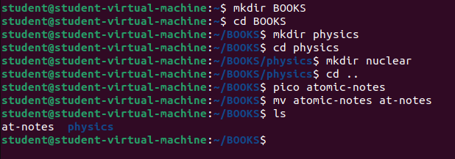

1. **Copy this file to sub-directory nuclear under the directory physics**

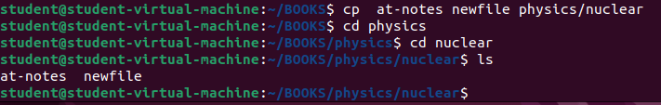

1. **Removed Write(w) permission for owner (user) from file result.comp.**

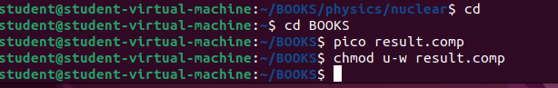

1. **Group and other get execute access for file stock.**

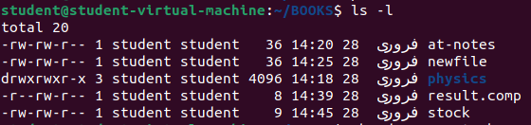

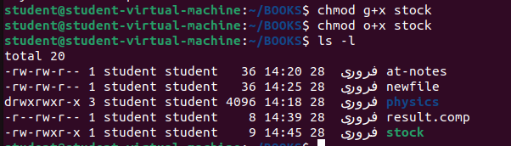

1. **Set group access for reading(r) and execute(x) of myfile.**

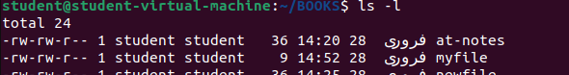

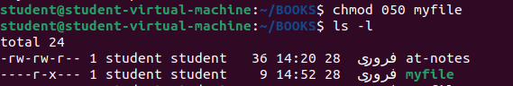

1. **Create a directory called lab4 and create three files say quiz, report and viva inside the directory**

## Now try to set the following rights;

## -rw- r-- r- quiz

**-rw- -w- r- - report**

## -rwx rwx r-x viva



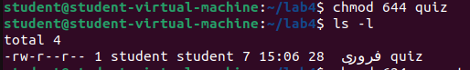

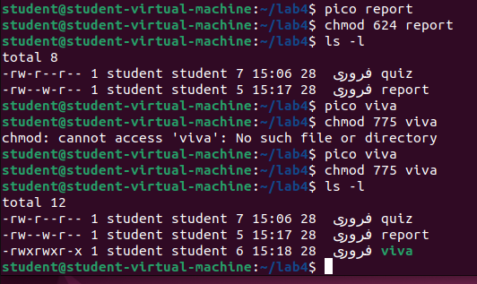

**Also try to change access permission of lab4 directory as well and see how it affects.**



